FoodRescue Connect: Smart Food Donation and Redistribution Management System

Git & Docker Technical Assignment

Submitted partial fulfilment for the Course of

CSA1012 Software Engineering
to receive the award of the degree of
ARTIFICIAL INTELLIGENCE AND MACHINE LEARNING

Submitted by Ramana Y (192525476)

Under the Supervision of ANITADAVAMANI K



SIMATS ENGINEERING
Saveetha Institute of Medical and Technical Sciences Chennai-602105
August-2026

PROBLEM, OBJECTIVES AND PROJECT DESIGN
1. Introduction
Food waste is a major problem because large amounts of edible food are discarded while many people still face food insecurity. Restaurants, supermarkets, hotels, event organizers, and other organizations often have surplus food, but there is no simple and efficient way to connect them with organizations that can distribute it.
FoodRescue Connect is a smart food donation and redistribution system designed to solve this problem. It connects food donors, NGOs, volunteers, and beneficiaries through one platform. Users can list available food, find suitable donations, arrange pickups, track deliveries, and maintain donation records.
The system can also use AI, IoT, GPS, cloud computing, and real-time notifications. AI can help with food allocation and route planning, while IoT can support food quality and shelf-life monitoring.
2. Problem Statement
Food is often wasted because donation and collection activities are handled manually. Delayed communication can result in missed pickups, food spoilage, and uneven distribution. NGOs may also find it difficult to identify nearby food sources.
FoodRescue Connect provides a centralized platform for managing donations and coordinating their collection and distribution.
3. Objectives
- Connect donors, NGOs, volunteers, and beneficiaries.
- Monitor food quantity, availability, quality, and expiry.
- Use AI for food allocation and route optimization.
- Send notifications for donations and pickup requests.
- Track collection and delivery.
- Generate donation and food-waste reports.
- Support sustainable food recovery.
4. System Design
The main components are the frontend, backend, database, AI service, and IoT integration. The backend connects the different services and manages communication between users.
5. Project Structure
FoodRescue-Connect/
├── frontend/
├── backend/
├── ai-service/
├── iot-service/
├── database/
├── docs/
├── docker/
├── .gitignore
├── README.md
├── Dockerfile
└── docker-compose.yml
The frontend handles the user interface, the backend manages APIs and application logic, AI handles intelligent allocation, IoT handles sensor communication, and Docker files support deployment.

GIT, GITHUB AND DOCKER
6. Git and GitHub
Git is used to track project changes and maintain the development history. GitHub provides the remote repository for storing and sharing the project.
Basic setup:
git init
git add .
git commit -m "Initial project setup"
git branch -M main
git remote add origin <repository-url>
git push -u origin main
A feature-based branching strategy is used:
main
│
└── develop
├── feature/user-management
├── feature/donation-management
├── feature/ai-allocation
└── feature/route-optimization
Features are developed separately and then merged into the development branch. Example commits include:
- Initial project setup
- Add user authentication
- Add donation management
- Implement AI food allocation
- Add route optimization
- Add Docker configuration
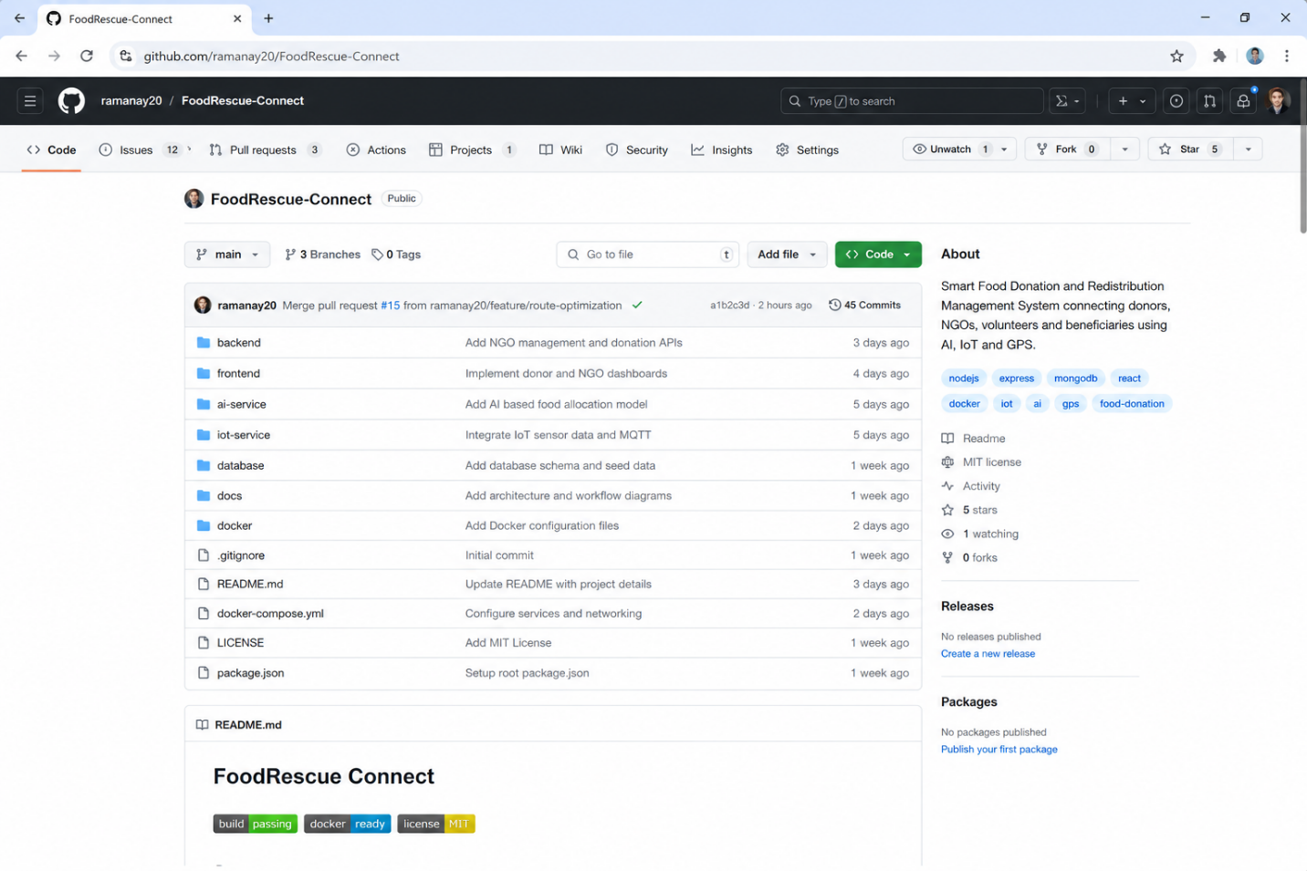Figure 2: FoodRescue Connect GitHub Repository
The Git process provides version control, easier collaboration, and a clear record of project changes. The assessment specifically requires repository initialization, branching, meaningful commits, merging, synchronization, and commit-history analysis.
7. Docker
FoodRescue Connect contains several components with different dependencies. Docker allows these components to run in separate and consistent containers.
The main services are:
- Frontend
- Backend
- AI service
- Database
- IoT/MQTT service
Example Dockerfile:
FROM node:20-alpine
WORKDIR /app
COPY package*.json ./
RUN npm install
COPY . .
EXPOSE 5000
CMD ["npm", "start"]
Docker Compose can be used to start the services together.
docker compose build
docker compose up -d
docker ps
docker compose build creates the images, docker compose up starts the services, and docker ps verifies that the containers are running.
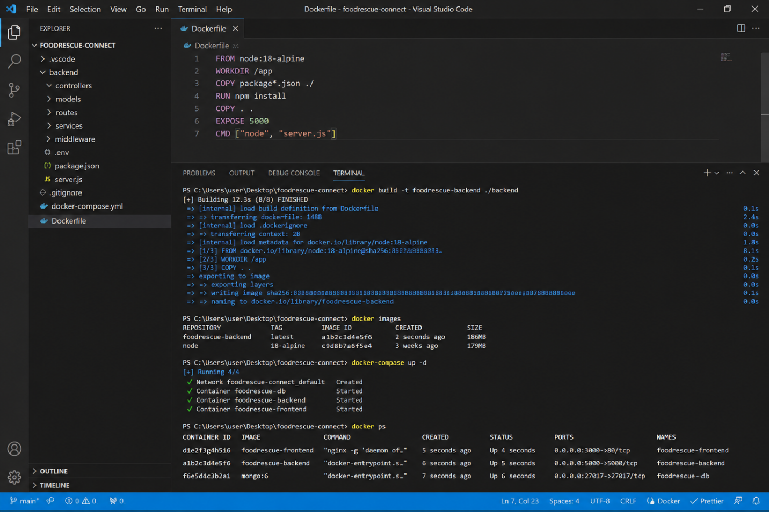
Figure 4: Docker Build and Running Containers
The assessment requires Docker environment design, Dockerfile development, Compose configuration, and successful container testing.

WORKFLOW, RAPTOR, JIRA AND CONCLUSION
8. Git and Docker Workflow
The complete development process is:
Developer → GitHub → Docker Build → Docker Compose → Running Application
The developer first works on the project and commits changes using Git. The code is pushed to GitHub for version management. Docker then builds the application environment, while Docker Compose starts the required services.
Figure 5: Git and Docker Development Workflow
9. RAPTOR Workflow
RAPTOR is used to represent the logical flow of the FoodRescue Connect system.
The basic flow is:
Login → Select Role → Add/Find Donation → AI Allocation → Pickup → Delivery → Completion
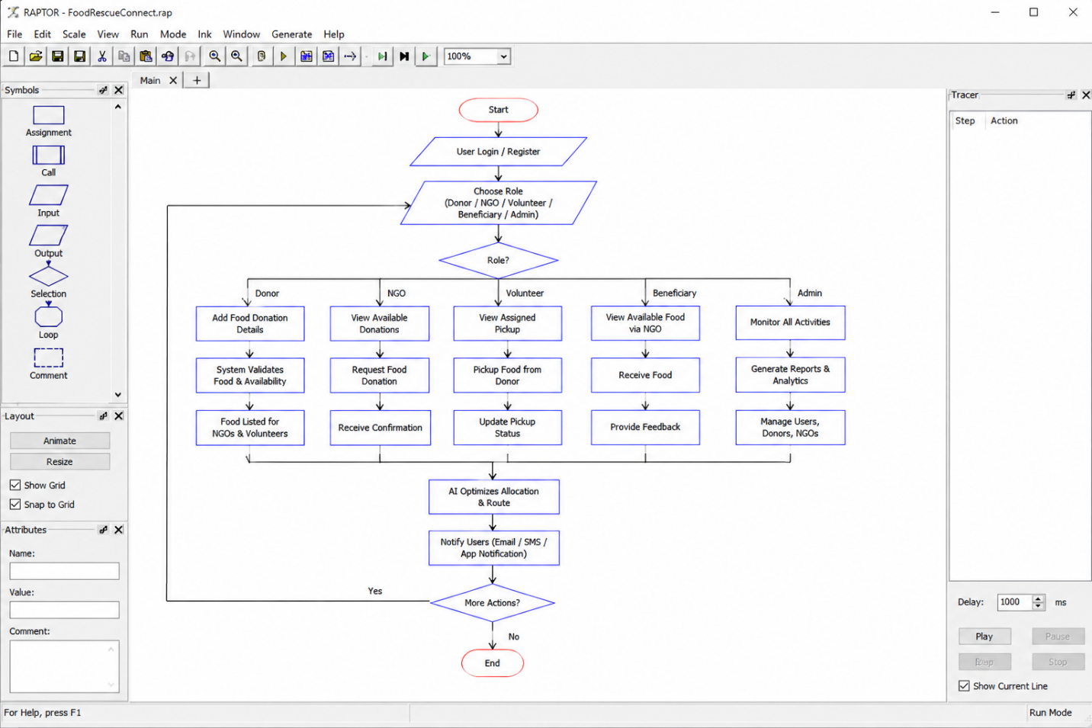Figure 6: FoodRescue Connect RAPTOR Flowchart
10. Jira Project Management
Jira can be used to organize the project tasks. Development activities can be divided into simple stages such as To Do, In Progress, and Done. Tasks can include user management, donation management, AI allocation, route optimization, and notifications.
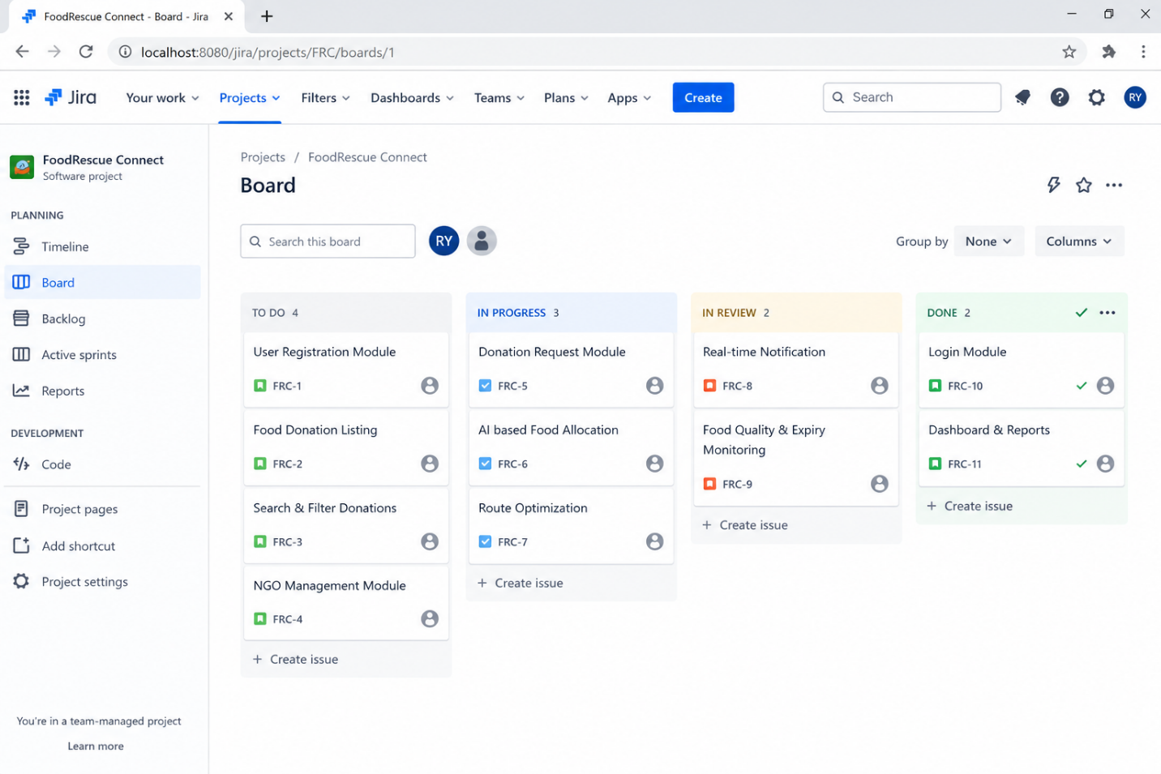Figure 7: FoodRescue Connect Jira Board
11. Testing and Results
After Docker deployment, the following checks can be performed:
- Verify that all containers start correctly.
- Check the frontend in the browser.
- Verify backend connectivity.
- Check database availability.
- Test communication between services.
- Test donation creation and retrieval.
- Test pickup and delivery operations.
Successful container execution shows that the application can run in a consistent deployment environment.
12. Benefits

Docker provides a consistent environment, dependency isolation, portability, easier deployment, and better maintainability.
Using both technologies gives FoodRescue Connect a more organized development and deployment process. These benefits correspond to the assessment requirements for collaboration, version management, portability, deployment, scalability, and maintainability.
13. Challenges and Future Improvements
Some challenges include Git merge conflicts, managing multiple branches, Docker networking, service dependencies, environment configuration, and coordinating AI, IoT, and database services.
Future improvements can include automated CI/CD using GitHub Actions, cloud deployment, improved AI prediction, real-time GPS tracking, better shelf-life prediction, advanced route optimization, and container monitoring.
14. Conclusion
FoodRescue Connect provides a practical way to reduce food waste by connecting donors with NGOs, volunteers, and beneficiaries. The system combines intelligent food allocation, tracking, notifications, and logistics management to make redistribution faster and more organized.
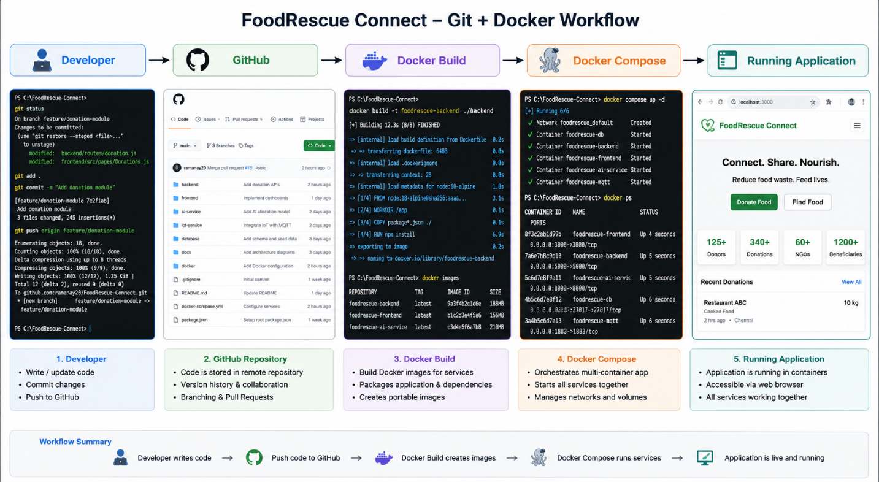
RAPTOR helps visualize the system logic, and Jira provides a simple way to manage development tasks.

